Youth Investment Council Minutes
9/12/23
Attendance: Greg Freelon; Chair Fran Kuhn Sherrise A. Moten Cynthia Torres Candace Titanski
Dr.Charles Wallace III Captain Stacey Schlachter
Absent: Kamani Blackmon Steven King Seyanni Godfrey Kelly DeCurtis Geoffrey Dorsey
Gina DeMaio Apreah Parks Dan Brown Odinga Maddox Nina Stolzenberg Ren Parikh

The Chair began the meeting at 4:00pm with a roll call. Open discussion on the minutes and he requested a vote , motion by Ms. Torres and seconded by Ms. Titanski , hearing no questions the motion passed. Mr. Freelon discussed the youth Board membership with Kamani, Steven and Seyanni. Kamani is now attending Stockton University , Steven is attending Atlantic Cape Community College and how we would be required to maintain youth participation.

Mr. Kuhn discussed the RFP for Out of School Youth and the award of only one contract to IDEAL Institute of Technology in the amount of $600,000, with a LOS of 79 participants. He mentioned last year’s LOS was 140. The ACWDB is operating with one vendor and will wait until amendments are necessary.

Mr. Kuhn discussed new budget approvals in the amount of $434,000 for at risk youth within the community. His update included the NJ Youth Corp confirming the award of the Urban Gateways Funding. This funding will include associating the youth with the Division of Motor Vehicle and landscaping opportunities.

Ms. Torres provided an update from the YouthWorks Unit.
The report included 16 youth and young adults hired in permanent positions due to their participation in the summer program out of 234 students.
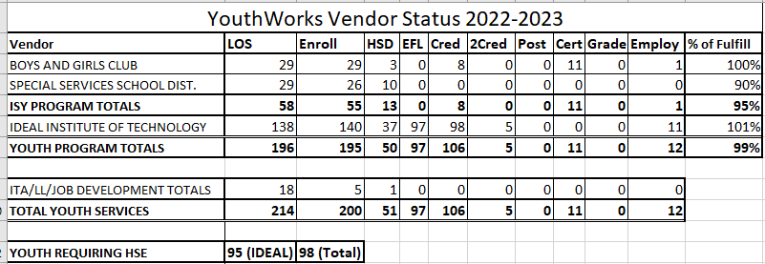
Ms. Torres reported on the Bridges contract with Jewish Family Services confirming 10 files have been processed to date.
Mr. Freelon discussed increasing youth participation with ambassadors in the community and his continued effort to keep the youth engaged. He agreed to maintain his connection with ACBGC and report back to the membership.
Dr. Wallace announced the Atlantic City Boys and Girls Club submitted a grant application for 18-24 SNAP individuals to assist them with receiving industry valued credentials. This grant will aid them in achieving certification in the workforce space that will help with the two generational approach of the Club.
Mr. Kuhn confirmed that ACSSID report provided by Ms. Torres included nine roll over students. This will aid in increasing skills after graduation.
Old Business: NONE
New Business CareSparc will host the Sustainable Health and Wellness event at Showboat. Friday is seniors day and Saturday is designated for the youth. Free event and services are available.
Mr. Kuhn concluded the meeting by requesting information from the members on any opportunity that the ACWDB may be missing to connect within the community. Please share information so we can place it on the calendar to attend.
The Chair requested a motion to adjourn, motion by Dr. Wallace second by Ms. Titanski. Meeting adjourned at 4:45pm.

Next meeting December 12th 4:00pm.
Submitted by
Sherrise A. Moten
Contract Administrator/ Board Liaison

