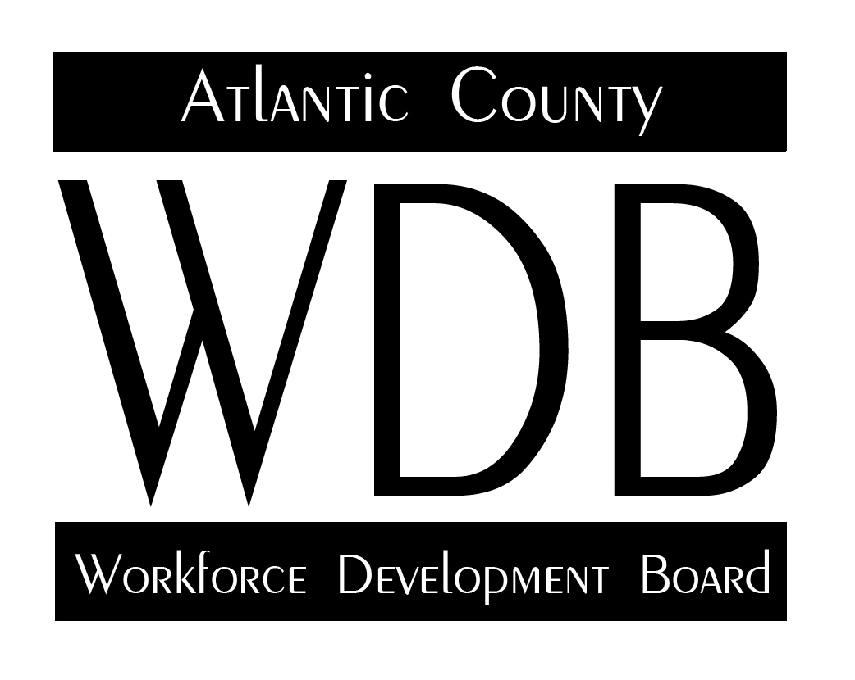

2 South Main Street 2nd Floor Pleasantville, NJ 08232

Telephone: 609.485.0153 Fax: 609.485.0067

November 2, 2023

Attendance : Fran Kuhn, Karen McCormick, Maryann McGhee, Forrest Gilmore, Paul McClean and Micheal Pompei , Sherrise A. Moten

The meeting opened at 2:35 by Mr. Kuhn and requested an approval of the August minutes, motion by Mr. McClellan second by Ms. McGhee no questions or comments motion approved.

* The meeting discussed various training programs and their outcomes, including adult dislocated workers, youth services, and workforce New Jersey.
* The dealer school program has been successful in hiring trainees, with 20 people being employed by values or resorts.
* There have been high no-show rates for testing appointments, particularly among the public assistance population.
* The unemployment office has seen increased traffic with a steady increase in walk-ins.
* There are challenges in engaging the homeless population in work activities, as their immediate needs are focused on finding shelter and food.
* There is a need for more accountability regarding the use of bus passes provided for transportation to work activities.
* Various contracted programs, such as literacy services and youth programs, are underway with good enrollment numbers.
* The business development committee has registered 35 businesses and is looking to expand partnerships.
* The group has 3 people working with Mud Girls, which is also a nonprofit.
* They are providing funding for a small grant to bring a social worker on part-time to support trauma-informed therapy.
* They have been successful in upskilling incumbent workers through training programs and assisting individuals pursuing apprenticeships and electrician contract.

**Actions taken:**

Explore using a texting service to send reminders to scheduled testing appointment and address the high no-show rate

Track the reasons fro no-shows in order to determine if there are issues with the public assistance population or any other factors.

Take a closer look at the adult dislocated workers population to determine if there are any consequences for non- compliance.

Review and sign additional contracts for work activity programs and determine if the finding for the ESL program with Atlantic Cape will continue.

Explore the possibility of providing chauffeured service and trauma-informed therapy for work activity participants.

Discuss workspace learning with the business development committee and continue expanding partnerships with businesses in various industries.

Send contact information for the dealer to Michael Chait.

Make the connection between Trina Byrd and Michael C. for the dealer school recruitment in Pleasantville.

Motion requested by Mr. Kuhn, motioned by Mr. McClellan seconded by Ms. McGhee. Motion passes.

Next Meeting July 3, 2024

Submitted by,

Sherrise A. Moten

Contract Administrator/Board Liaison