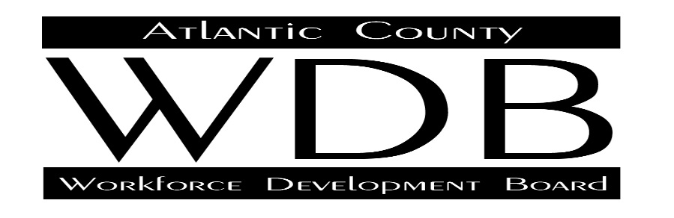

2 South Main Street 2nd Floor Pleasantville, NJ 08232

Telephone: 609.485.0153 Fax: 609.485.0067

**MEETING MINUTES**

Full Board Agenda

12-11-19

Call to Order: 9:10 am

**Members Attending**:

Dan Kelly Jim Drew Maryann McGhee Joe Kelly Joe Ingemi

Pat Constantino Paul McClellan Phil Guenther Torrie Garvin Riaz Rajput

Stephanie Koch Theresa Lutz Candace Titanski Fran Kuhn Marian Woodson

Forrest Gilmore

I. Call to Order-Riaz Rajput: Chair - meeting was called to order at 9:10 am.

II. Approval of Minutes – minutes were reviewed and approved- motion by Mark Ford and seconded by Paul McClellan..

III. Financial Report- Mr. John Fata reviewed the documents sent to board members. He stated that the total expenditures to date reflected a reduction. Current expenditures at the six-month mark showed an expenditure rate of 28%, or $2,568,401. He stated that one of the reasons for the reduction was contracted services which would not submit second quarter invoices until early 2020. The current report being used showed expenses as of the end of November 2019. Mr. Fata then reviewed the fund level analysis for the ITA contracts. He also stated that the information reflected in the reports showed the number of trainings initiated, but did not show the number of trainings completed because of the timing of the report in comparison to the length of the training contract.

Motion to approve the financial report made by Dan Kelly and seconded by Jim Drew. Financial report was approved.

IV. Chairman’s Report: Riaz Rajput thanked everyone for attending and spoke briefly about the services and importance of the workforce development board. The chair also reported on the regional board meeting held at Rowan College of South Jersey. This regional meeting’s guest speaker was NJDOL Commissioner Robert Asaro Angelo.

Jim Drew- Employment Center Manager for Borgata Casinos stated that he has enjoyed his time on the workforce development board and has learned a great deal. He stated that he felt that it was very important, because of his position, to become more involved in the workforce development system and truly has enjoyed his time with the board.

Terri Lutz is the AVP of Marketing at the Tropicana Hotel and Casino, a Caesars business, has been involved with the Atlantic County Workforce Development Board for the past four years. The biggest reason she wanted to get involved was to become an advocate for people that had experienced job loss and the struggles associated with trying to find a new job and career. She felt that it was important for the agency to become more proactive in helping customers receive the proper training to prepare them for employment.

V. Executive Director Report – Fran Kuhn indicated that as the new acting executive director of the Atlantic County Workforce Development Board,that he wanted to use the expertise of the board members to provide future direction for the board’s goals and objectives. He also stated that it was imperative that he board received regular performance reports to provide evaluative tools on the success of the programs. He did state that, as was indicated in the report found in the packet, Atlantic County was performing well on those issues that related to our state performance benchmarks.

Grants- Most recently, the New Jersey Department of Labor has introduced a regional hospitality and leisure RFP for $500,000, that is due in January 2020. The RFP focuses on training and employment in Atlantic City.

Mr. Kuhn expressed concern with the efficiency of the ITA contract because, as the board has recognized, many times training completion does not result in jobs. The agency director stated that the management team is working to develop increased opportunities for OJT because of the direct connection to the employer and earning while you learn.

The Acting Executive Director stated that he wanted all board members to be involved in creating the policy and direction of the services. In an effort to further educate all board members to the services of the One Stop, the next meeting will be held at the One Stop Career Center where an orientation and tour of the building will be held.

Finally, the director requested volunteers for an ad hoc committee to work on amending the current by-laws.

Committee Reports:

Disability: Joe Ingemi-Chair, No meeting this quarter. Did state that the disability banquet was great. Goals established for 2020, focus on transportation, autistic customers, wounded warriors and eldercare.

Membership: Torrie Garvin-Chair. Membership has 3 openings; Torrie will speak to other private sector candidates.

Business and Economic Development: Joe Kelly- Stated the focus is the current economy and changing the business model and employer engagement to attract employers.

Youth Advisory Council: Stephanie Koch- Youth meeting held. Focused on apprenticeship; discussed current GAINS RFP offered in January 2020.

VI. Old Business-

VII. New Business: Joe Kelly was recognized for his service to the board for the past 10 years. He was provided with a plaque and thanked for his years of service. He is retiring now.

VIII. Adjournment: the meeting was adjourned at 10:30 am.

Next Meeting will be held at Harbor Pines, March 25 at 9am.

If you cannot attend, the call in number is: **(712) 770-4856. Access Code is: 528959.**