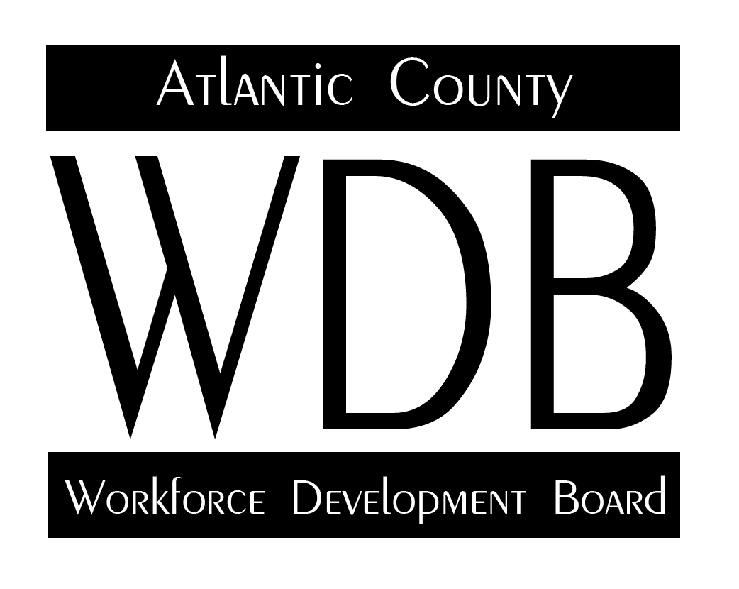

2 South Main Street 2nd Floor Pleasantville, NJ 08232

Telephone: 609.485.0153 Fax: 609.485.0067

ACWDB Healthcare Subcommittee Minutes

8-13-2020

Members Attending: Fran Kuhn Alan Beatty Lillian Smith Sherwood Taylor

Meeting began at 3:35 pm..

Initial discussion involved the impact of the pandemic on the local economy and the documents sent prior to the meeting. Primary focus of meeting was on increasing awareness of the committee members of the magnitude of the problem and begin looking at the employment alternatives for those dislocated workers in and around Atlantic County.

**Hospital-Related Jobs:**

Fran Kuhn initiated the discussion by asking how the pandemic had impacted the healthcare services, specifically the hospitals. He further inquired as to where there were increased demands for workers as a result of the virus. First Alan Beatty, then Lillian Smith, responded that the impact of the pandemic had not increased demand overall, and in fact had reduced the demand because of the use of virtual mediums for delivering services and patient interaction. As a result, the prior demand for medical assistants, while still important, was not nearly as urgent as it had been in the past. There was agreement from both Mr. Beatty and Ms. Smith that there was a need for workers with technical knowledge on the use of information technology, especially as it relates to virtual services, however, the need would be limited to only a few positions. Overall, both Alan Beatty and Lillian Smith stated that staffing needs had been reduced as there were fewer appointments and with the use of video conferencing, there was less need for supportive medical services. Upon further discussion during the meeting, Alan Beatty did indicate a need periodically for phlebotomy services, but those services would be provided by someone who is also certified as a medical assistant.

**Healthcare Training:**

Sherwood Taylor of Atlantic Cape Community College reported that there was no problems with the fall registration for the college’s medical assistant program. He also stated that he was beginning a Certified Pharmacy Technician program as part of the community college’s scaling apprenticeship program. The program is responding to the needs of its employer partner, CVS who will be providing the on-the-job learning component of the apprenticeship. Both Alan and Lillian indicated that it was a need of their respective hospitals. According to Mr. Beatty, Mr. Taylor and Ms. Smith, the hourly wage for a Certified Pharmacy Technician is between $13.50 and $14.50. Fran Kuhn asked it Mr. Taylor could provide him with information flyers to distribute to the One Stop staff.

Discussion then moved to the opportunities for career pathways. Sherwood Taylor expressed concern with the emphasis on career pathways as many of the students were not interested in pursuing anything other than the skills of their current class. Using the example of CNA, he stated that some of the people who completed the course would love the job and stay there forever, while some would not want to continue up the industry ladder because they were not truly interested in continuing in the healthcare field. He believed that students who became medical assistants, were not interested in becoming a nurse and were comfortable with being a medical assistant. There was further discussion as to whether or not there was any validity in the presumption that becoming an LPN or RN was a normal progression from a CNA. Fran Kuhn stated that he would see if there was any data that would support that premise.

Alan Beatty also indicated that the Shore Radiology cohort was beginning its fall semester in the near future. The course would take place over four semesters and approximately two years. There was also concern expressed by both Alan and Lillian that they were having difficulty obtaining respiratory therapists as there was no longer a local program to train workers in that skill. Fran Kuhn will contact the Southern Regional WDB directors to see if other areas are identifying similar concerns.

Meeting adjourned at 4:40 pm.

The next meeting will be scheduled for October 15th at 3:30. At present by video conference call.

Respectfully submitted,

Francis Kuhn