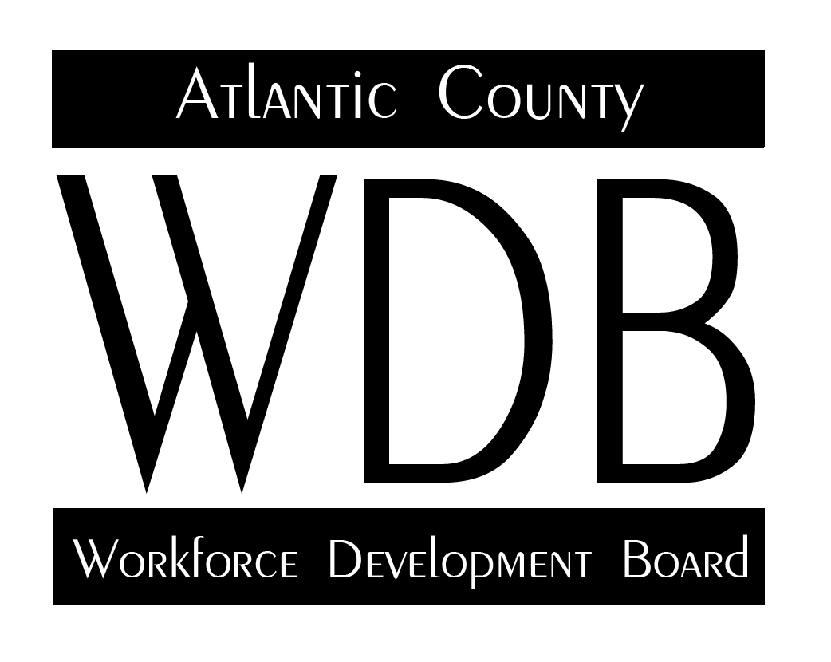

2 South Main Street 2nd Floor Pleasantville, NJ 08232

Telephone: 609.485.0153 Fax: 609.485.0067

Healthcare Subcommittee

Minutes

10-22-20

Attendance:

Alan Beatty Sherwood Taylor Lillian Smith Myrna Keklak Francis Kuhn

Meeting began at 3:32 pm.

Minutes:

Minutes for the August meeting were reviewed, motion to approve the minutes made by Alan Beatty and seconded by Sherwood Taylor. Minutes were unanimously approved.

Discussion Topics:

1. Overview of Economic Impact of COVID 19

Group discussed the current impact of the pandemic. Stated that there has been an increase in the amount of activity within the hospital setting and that while the use of telemedicine continues, there has been an increased demand for medical assistants in the hospitals. This was especially noted by Lillian Smith of AtlantiCare. There was additional discussion with Atlantic Cape/Sherwood Taylor about plans going forward for additional training to meet the need for medical assistant staffing. Overall, the healthcare providers indicated that there was an increase in the amount of activity within the medical centers.

1. Healthcare Industry Needs

As a follow-up to the prior meeting, the group then discussed the need for respiratory therapists within the local hospitals. This has been an ongoing need for the past several years because there is no training program available in the area. In the recent past, plans were in place for Stockton to establish a bachelor level respiratory therapist program, however, after several planning meetings and continuing discussions, Stockton abandoned the program as it was deemed cost prohibitive.

Other recent plans involved Atlantic Cape partnering with Brookdale Community College to create a joint training program. Brookdale currently offers respiratory therapy training in Monmouth County, however, efforts to establish a working relationship with the college to bring qualified staff to the Atlantic County area have stalled. Atlantic Cape expressed interest in making attempts to once again pursue the partnership with Brookdale to explore future possibilities. Fran Kuhn indicated that he would survey other south jersey workforce development areas to see if they were experiencing these same kind of shortages.

1. Training Solutions

Sherwood Taylor from Atlantic Cape reported on the progress with the planned scaled apprenticeship training for the pharmacy tech job title. He indicated that the apprenticeship program had been suspended because there were no jobs available locally to establish the apprenticeship program.

Myrna Keklak of Atlantic Cape stated that the registered nursing program is robust and very active. Recent admissions included 128 new students and a total enrollment of 231 students for the fall semester. Comments from Alan Beatty of Shore Memorial and Lillian Smith of AtlantiCare both indicated that the nurse population was pursuing retirement more aggressively in the past several months. Ms. Keklak has additional information in her report which is attached to these minutes.

Other areas of training include 17 new students for the radiology program with 31 overall; and reaccreditation of the medical lab technician program.

Old Business:

There was no old business.

New Business:

There was no new business.

Adjourn.

The meeting was adjourned at 4:28 pm.

Respectfully.

*Meeting will be held by Webex invitation.*