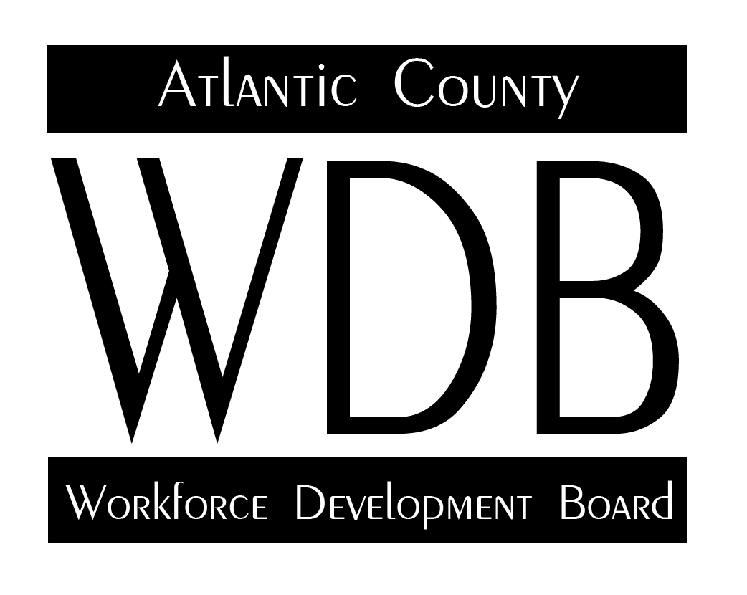

2 South Main Street 2nd Floor Pleasantville, NJ 08232

Telephone: 609.485.0153 Fax: 609.485.0067

One Stop Oversight Committee Minutes

8-4-21

Members Attending:

Dhara Bachman Maryann Mcghee

Jim Waters Fran Kuhn Marian Woodson Forrest Gilmore

**Review of Minutes:**

The oversight committee meeting began at 2:34pm. Marian Woodson moved to approve the April meeting minutes, seconded by Jim Waters. Minutes were approved.

**One Stop Operator Report:**

Marian Woodson reported on the Employment and Training activity. Since the last meeting, the agency had processed 462 interested individuals with only 31 of them being ineligible. All felt that that was a good number. Director Kuhn stated that it was very helpful to receive all of the referrals from our state partners via MS Teams and estimated that the One Stop was receiving 10-12 per week.

Ms. Woodson discussed the New Jersey Youth Corps group. The activities associated with the Youth Corps were focused on those that successfully passed the high school equivalency test. It was noted that the HSE data was not available at this time, but it would be obtained for the next meeting. According to the presented data, there were 16 youth enrolled in the program, which finished in June. At the time of the meeting, 14 of the 16 youth had successfully completed the HSE

Ms. Woodson also discussed the numbers for YouthWorks and the four contracted providers. In total, there were 91 Out-of-School Youth served and 52 In-School Youth served. Due to the pandemic, performance in all areas was limited. Of note was the number of youth who had documented measurable skill gains, with much more limited success with credential attainment and high school equivalency.

For literacy services and the TASC testing, the agency noted 28 successful acquisitions of the high school diploma as a result of the coordinated support of all aspects of the agency. Those aspects include remediation, support from employment and training, as well as testing services.

Ms. Woodson reported that DVR was working remotely and had been providing services through telephonic and video communications.

Reporting on the summer youth employment program, there are 39 participants in the program. This is significantly less than the level of service at 80. The explanation involves the current state of affairs with the pandemic, the increase in wages and the duration of the program. All of these factors are competing with area employers who are offering higher wages and longer opportunities with signing bonuses.

For WorkFirst New Jersey, the Foundations for Success program has involved over 150 voluntary public assistance customers with 52 people starting in February and 38 having completed the program. The agency intends to continue the program into this new program year because of the customer’s voluntary response.

**Director’s Report**:

Discussion regarding the re-opening of the One Stop Career Center. The state’s planned re-opening is scheduled for early September, possibly. There was also some discussion that it could be later. Hugh Bailey had indicated that the state is planning a marketing plan for the announcement of the return to work. The Director indicated that the most recent numbers for the number of county residents who will exhaust their unemployment in early September was approximately 8,400. There are concerns that they will be approaching the One Stop Career Center to address the questions that they have about their unemployment. There have been a number of discussions related to security measures, including cameras, metal detectors and increased security presence. The local areas are also posting their own signs informing people that there are no unemployment workers in this building.

Additional concerns involve having a large number of customers coming to the office following their loss of unemployment benefits. Efforts have been made to prepare the resources of the One Stop to address the employment and training needs of those people and utilize the newly created Job Development unit to assist in identifying employers who have talent and staffing needs. The additional concern is the resulting impact of the season ending and the loss of seasonal job opportunities.

As customers enter the building looking for training, the first focus will be to direct them toward current job opportunities rather than pursuing training. There is a current effort to develop OJT contracting to provide ‘earn while you learn’ scenarios for employers and employees.

Director Kuhn announced that the new Out-of-School Youth contract has been awarded with the contracts going to Ideal Institute of Technology and Jewish Family Services. In addition, there are literacy contracts currently in place with Atlantic Cape to address the needs of the ESL population and the lower learning level customers.

Director Kuhn stated that Work First New Jersey services remain voluntary at this time, but expressed concern with a start date of January 1, 2022, because of the number of activities that would have to be established before a mandated system could become operational. He also said that there was a lot of continuing discussion related to voluntary services and the opportunity to engage the customers in beneficial services that will position the customers for available jobs. He suggested that perhaps there could be a program developed specifically targeted to Job Readiness services so that the customers are positioned for hiring consideration.

Forrest Gilmore suggested that the WDB consider engaging the community-based organizations to provide services to the members of their community. He expressed the idea that the link between the community-based organizations and the members of the community who are receiving public assistance. Director Kuhn continued that discussion considering the possible applications of the concept and stated that he could explore possible options.

**Provider Updates**:

Ideal stated that they were beginning their recruitment for the new year. They are offering all modes of services including on-line, in-person and a hybrid program. Dhara also stated that they are offering free GED classes to adults free of charge and are operating a youth, PACE and veterans’ program. They are providing the classes and testing at their own expense. Director Kuhn also mentioned that Ideal has an Occupational Partnership Grant with the state for Construction Training associated with the construction union. Dhara also mentioned that they have a relationship with Mahogany to provide advanced manufacturing training.

The conversation continued to discuss various aspects of engaging the community-based organizations in the Work First New Jersey work activity process with a number of suggestions arising from the content. Plans were put in place to attempt to build a listing of community-based organizations that would be interested and capable of participating.

The meeting adjourned at 3: 38 pm.

Respectfully submitted.

Director Kuhn expressed concern about the environment that is currently in place and hopes to have changes to the resurgence of local business in Atlantic County.

The director mentioned the completion of the second cohort and we hope that the line school will actually be held before the end of April, or the beginning of May.

The meeting concluded at 3:34pm.

Respectfully submitted,

Francis F Kuhn