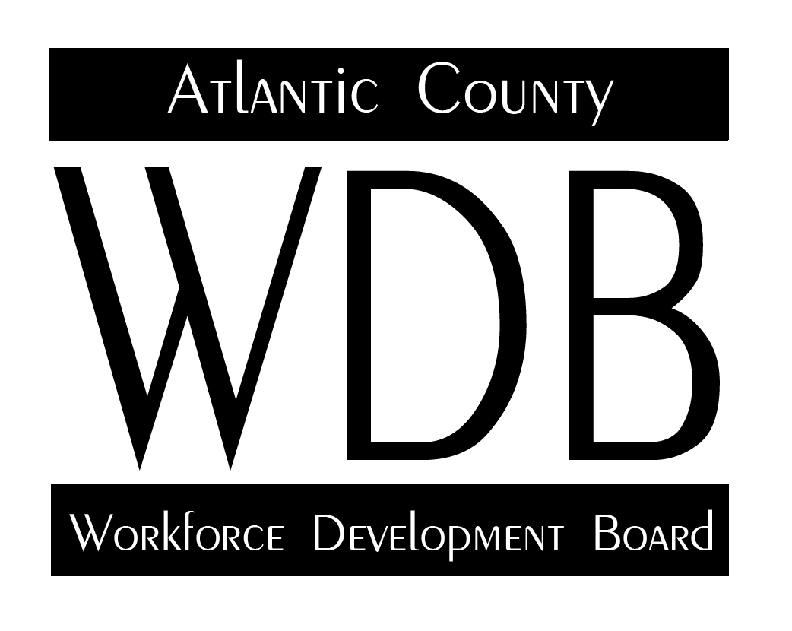

2 South Main Street 2nd Floor Pleasantville, NJ 08232

Telephone: 609.485.0153 Fax: 609.485.0067

Youth Investment Council Minutes

3-16-21

Attendance:

Neal Bellinger Diana Strelczyk Anne Dillon Claire Millar Ren Parikh

Tim Kreischer Sherwood Taylor Torrie Garvin Leesa Seymour Reverend Maddox

Joe Ingemi Gina DeMaio Connie Price Dan Konczyk Michael Margraf

Meeting began at 9:32 am. Minutes have been provided from the 11-5-20 meeting. After a brief discussion, the motion to approve the minutes was made by Torrie Garvin and seconded by Neal Bellinger.

Executive Director Kuhn began the meeting by discussing the recent history of prior meetings stating that there had only been two in the prior year and that the requirements of WIOA and the SETC establish the expectation that there should be quarterly meetings. Meetings during the past year were primarily informational and did not establish a strategy or a plan to move forward. It is the intent of the director to use the youth subcommittee as a planning and operations vehicle moving forward to address the needs of the WIOA youth population and implement operational strategies to effect those strategies. Because the meeting also consisted of new board members, the director provided a brief overview of the purpose of the Youth Investment Council. WIOA requires that the majority of services be provided to Out-of-School Youth, with 75% of funding targeted to that population. Only 25% is targeted to In-School-Youth.

Director Kuhn then addressed the current unemployment situation in Atlantic County, stating that the unemployment rate was at 15.4%. He also mentioned that many of the areas casinos were looking for staff to help with the upcoming season. As an example, he mentioned that the Tropicana had recently posted jobs for seventy housekeeping staff and thirty security positions, stating that the employers were beginning to look at workforce development to meet their staffing needs. He also stated that the objective of workforce development was to create a categorized labor pool of workforce candidates that could be referred to the employer for consideration. Of primary concern currently, however, was the willingness of the current labor force to return to work as there were several factors motivating current workers to stay home. Those factors included the risk of the pandemic, childcare and unemployment payments in excess of their current earnings while working. Director Kuhn felt that this would be a golden opportunity to youth and young adults who were willing to work to find gainful employment. He also stated that there was a window of opportunity at present that would probably not be there in September.

Torrie Garvin mentioned that Atlantic City Boys and Girls Club intends to hold a job fair in early May and was offering to partner with anyone who was interested in participating with them. Ren Parikh of Ideal Institute stated that they had a number of mini-job fairs with advanced manufacturers where the youth were interviewed and hired on the spot. He stated that the youth had been screened by Ideal and then referred to the employer. He stated that four had been hired at $15 per hour. Ideal intends to proceed in small groups with candidates that they have pre-screened and pre-qualified.

Youth Updates:

Ideal continued saying that they have been very successful in recruiting youth recently. He stated that they currently have roughly 75 youth enrolled with 22 having an increase of one EFL and 9 successfully completing the High School Equivalency exam. He stated that he has six job placements and anticipates another four in a week or so. Five youth will receive industry certification and two youth have been accepted at ACCC tuition free. He also said one of their youth went to Pennco Tech to be an electrician. He also stated that he is working with the high schools to possibly provide an alternative location for those youth who are on the verge of dropping out.

Anne Dillon of ACSSSD stated that classes in special services has been going quite well considering the challenges of the pandemic. She stated that there is difficulty with community work experience, which is a primary component of the program, but they are adjusting those experiences to the virtual platform and having presenters and videos take the place of actual experiences. She did state that two students had been hired by Tropicana for security and one is still employed there. She anticipates 13 or 14 graduates of the program this year.

Diana Strelczyk of Stockton University reported on their program. She stated that the program was currently undergoing some restructuring as they had recently furloughed several staff and were working to orient new workers to the program. She stated that recent recruiting efforts had resulted in two or three new enrollees that brought their total up around 11. They are working on the high school equivalency programs and other new online opportunities including life skills programming.

Torrie Garvin of Atlantic City Boys and Girls Club spoke of their experience during the past year. He stated that they were currently serving 340 children with 148 between the ages of 13 and 18. Mr. Garvin discussed a number of activities that the youth were involved in including robotics, technology and E-sports gaming. He also stated that seventeen youth had completed the Serv Safe credential and were focusing in the ServSafe Manager credential going forward. He also spoke of forward progress on their healthcare track and hoped to have most of their certifications completed by mid-April.

Reverend Maddox spoke about the New Jersey Youth Corps: He stated that 25 youth have been enrolled, 13 have successfully completed the high school equivalency with another six or seven that should succeed. Fourteen Corps members have completed their OSHA credential, nine have obtained full-time employment, three have enrolled at Atlantic Cape Community College and three are on various vocational training tracks. He also stated that the Youth Corps is pursuing the summer Urban Gateway program where eleven youth will be involved in the planning and development of roadside beautification including a large planter designed and created by the youth.

Director Kuhn them moved to job availability to discuss the current notification of job opportunities and how best to get the word out about available jobs. He spoke of Paul McClellan of Employment Services and his staff’s activity in searching their current labor pools in AOSOS to identify qualified candidates for job postings. He spoke briefly about the online postings that are gathered by the Office of Research and Information, but could not receive an explanation as to why many job postings were not included in those spreadsheets. Therefore, Atlantic County Workforce Development will be sending all job postings to its contacts. There may be some duplication, but it is better to have too many then miss some. Director Kuhn then stated that the ACWDB was interested in getting the word out on incentives that it could offer to assist employers with their workforce development needs. Those resources include- On-the-Job Training, Registered Apprenticeship, Incumbent Worker Training and Occupational Training. He also emphasized that the performance measures were no longer just based on achieving the high school equivalency, but now needed to include an accomplishment in addition to the diploma. That could include attendance in post secondary education or a vocational training program, but the diploma, by itself was not a countable performance measure for youth.

He also emphasized the importance of job readiness and soft skills in the development of the youth who is job ready. He also discussed the movement toward STEM and STEAM programs to guide the youth to the new planned industries of aviation, alternate energy and manufacturing. He stated that the current emphasis is on a multi-generational plan to move Atlantic County to diversify its industry and economy so that it is more resilient and less susceptible to hospitality-related jobs.

Diana Strelczyk mentioned Stockton’s interest in the cannabis industry and asked to there was any plan for the Department of Labor to assist in the development of those jobs. Director Kuhn stated that there continued to be concerns in that industry because the federal government has not de-criminalized marijuana. Therefore, federal funds could not be used for training purposes. Dan Konczyk also reported that he anticipates a number of jobs of various levels coming in to the area with this industry and stated that the union was seeing the same issues with employers having difficulties finding workers for those positions.

Director Kuhn also asked if Dan Konczyk and his union could make the connection to the local grocery stores to address their staffing needs as we move into the season. Mr. Konczyk said her would reach out to his contacts.

Geoff Dorsey also asked that he could help with the contacts for Out of School Youth program through his Friends in Action program for Out of School Youth referrals. Arrangements will be made to get that information to Geoff.

Also discussed was the plan for developing possible training programs for Atlantic City Youth to participate in a construction program in conjunction with Lincoln Tech and Ocean Inc. to train youth in construction trades. The concern was that the qualification for training was for a 12th grade level on the ABE assessment.

Director Kuhn also requested assistance with volunteers for the contract reviews that will be conducted in the next month.

New Business:

Director Kuhn stated that the Summer Youth Employment Program has recently been released and Atlantic County will be submitting a proposal. Anticipating funding for 80 youth for eight weeks of work.

Motion to adjourn the meeting made by Diana Strelczyk and seconded by Gina DeMaio.

Respectfully submitted.